Adil Ahmed

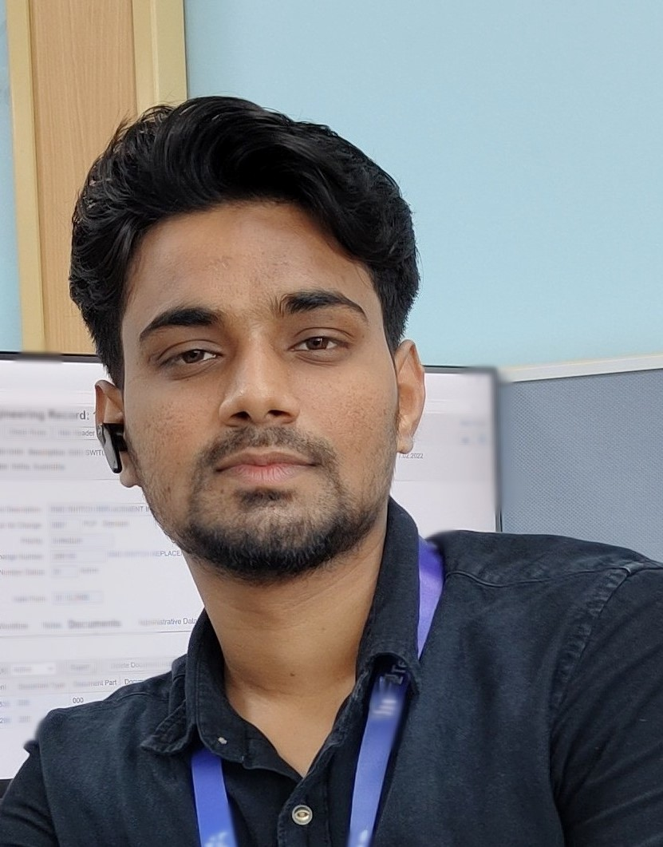

Full Stack Java Developer

**+91 8105880167** [**adilahmed0998@gmail.com**](mailto:adilahmed0998@gmail.com) **Bangalore-560105, Karnataka** [**www.linkedin.com/in/**](http://www.linkedin.com/in/) **adillahmed** [**www.github.com/Adil-Ahmed0998**](http://www.github.com/Adil-Ahmed0998)

# SUMMARY

Aspiring Full Stack Java Developer with a comprehensive 6-month training in web application development and Java programming. Eager to apply newly acquired skills in developing cloud-based web applications and solving real-world challenges. Proficient in back-end and front-end development and enthusiastic about contributing to innovative software projects. Committed to delivering results and continuously enhancing technical expertise.

Git Repository: <http://www.github.com/Adil-Ahmed0998>

# KEY SKILLS

* **Software Development • Web Application Development • Technical Analysis**
* **Object-oriented Programming • Process Optimization • Project Management**

# SECONDARY SKILLS

* **Multitasking • Teamwork • Critical thinking • Time management • Adaptability • Conflict Resolution • Communication**
  + **Project Management**

# TECHNICAL SKILLS

**Languages:** HTML, CSS, JavaScript, Bootstrap, Java

**Frameworks & Libraries:** AngularJS, Hibernate, Spring Boot(Java), Spring(Java),MVC

**Databases:** MySQL

**Operating Systems:** Windows

# EDUCATION

**Master's in Full Stack Java Developer**

**Simplilearn Certified in partnership with HIRIST & HackerEarth**

**Course Modules:**

* Object-oriented Java Programming: Data Structures and Beyond | Java Web Pages and Database Management
* Spring MVC and Advance Java Programming | Frontend Web Application Development | Web Application Testing and DevOps

**B.Tech in Mechanical Engineering : Academic Performance- 7.8 CGPA Reva University, Yelahanka-Bangalore**

**Diploma in Mechanical Engineering : Academic Performance- 7.0 CGPA Mahatma Gandhi Polytechnic, Yadgir**

**10th/Secondary : Academic Performance-87.5% Mahatma Gandhi High School,Yadgir CERTIFICATION**

**Certification in Computer Fundamentals | Simplilearn**

**Certification in Introduction to Programming and Data Structures| Simplilearn**

**Certification in Implement OOPS Using JAVA With Data Structures And Beyond | Simplilearn**

**Certification in Become a back-end expert | Simplilearn**

**Certification in Implement Frameworks The DevOps Way | Simplilearn Certification in Frontend Web Application Development | Simplilearn FULL STACK PROJECTS**

* **Project 1: Flyaway Airline Booking Portal | Tech Stack: Java, Java EE Servlets, JavaScript, MySQL, GitHub**
  + Coordinated with UX team to develop airline booking portal that generated 94% user engagement
  + Analyzed users' journey and modified existing portal to improve sig up rate by 13%

Jan '23 Delhi, IN

May '22 Bangalore, IN

Apr '19 Yadgir, IN Jun '16 Yadgir, IN

Feb '23

Jun '23

Jul '23

Aug '23

Aug '23

Sep '23

* **Project 2: Medicare Web Application for Ordering Medicines of Different Categories| Tech Stack: Java, Spring-boot, JSP, JavaScript, Bootstrap, MySQL, GitHub**
* Significantly increased user engagement by 30% , Streamlined user sign-in and Seamlessly integrated user-friendly features
* Empowered administrators with product management capabilities, including addition and deletion
* **Project 3: Kitchen Story (an E-commerce portal) | Tech Stack: HTML, CSS, JavaScript, Bootstrap, AngularJS, GITHUB**
* Engineered an **admin** login page with the capability of 80% for administrators to securely change **passwords** after login
* **Implemented** an intuitive food item management system that allows administrators to add or remove food items efficiently, resulting in a **50%** reduction in time spent on item management**, Enhanced** user experienc**e** by integrating a search form on the homepage, enabling customers to **effortlessly** browse and purchase food items, leading to a 20% increase in user engagement
* **Project 4: Administrative portal for learners academy| Tech Stack: Java, Java EE Servlets, JavaScript, MySQL, GitHub**
  + Efficiently engineered administrative functions, including the creation of master subject, teacher, and class lists, assignment of subjects to classes, allocation of teachers to specific subjects and classes, and management of a comprehensive student roster
* **Project 6: MyMoviePlan Application for online ticket booking | Tech Stack: Java, Spring-boot, JSP, JavaScript, Bootstrap, MySQL, GitHub**
  + Admin Portal Responsibilities: Manage backend data generation and product information, including adding/removing genres, editing movie details, and enabling/disabling movie shows to maintain a rich and up-to-date product line
  + User Portal Responsibilities: Facilitate user activities, such as sign-in, movie ticket search with filters and sorting, cart management for selected tickets, streamlined payment processing, and providing a booking summary page upon completion

# PROFESSIONAL EXPERIENCE

**Graduate Trainee Engineer - HCL | [Bangalore] | [Nov,2022]**

Nov '22

- Present

**HCL Technologies** Bangalore, IN

**Successfully transitioned from a student role to full-time professional through the company’s campus hiring program. Onboarded in HCL in Nov/2022.**

**Deployed on ASM based project in Dec/2022. Throughout achieved good Remarks, work pressure handling ability, Project management, Team working ability.**

# ADDITIONAL INFORMATION

* **Hobbies & Interests:** Photo Editing, Reading Novels, Music, Cricket, Badminton
* **Languages**: English, Hindi, Kannada, Urdu, Arabic